
School Of Engineering And Technology

Algorithm And Design Analysis

Submitted By :
Name : MANYA YADAV
Roll Number : 2401420012
Course :- B.Tech CSE (DS)
Semester : - IV
Department :- SOET

Submitted To :- DR. AARTI SANGWAN
Submission Date :- 9-April-2026
Course Code :- ENCS256

1.Backtracking Algorithms:-
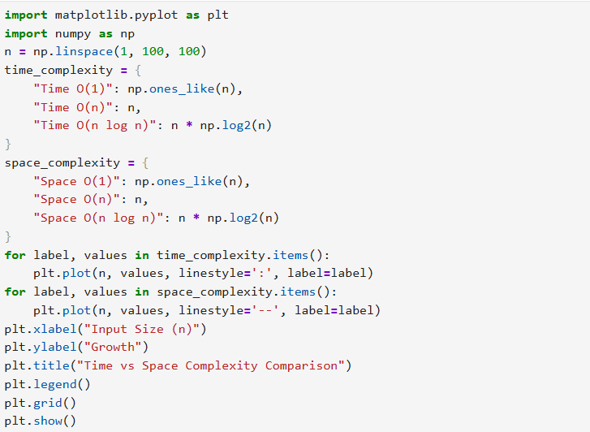
Output:-
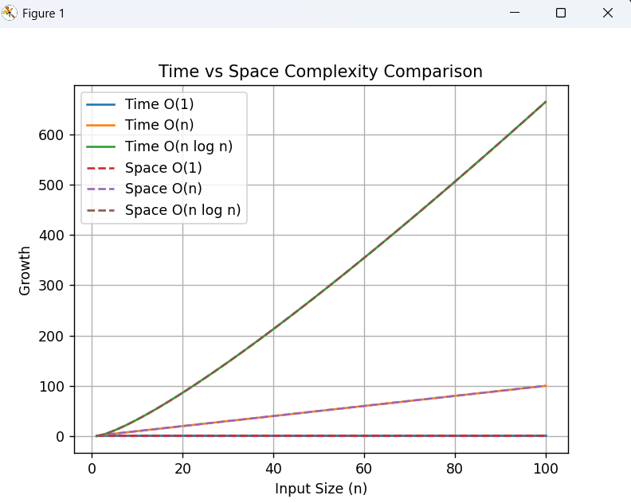

2.Branch and bound algorithms:-
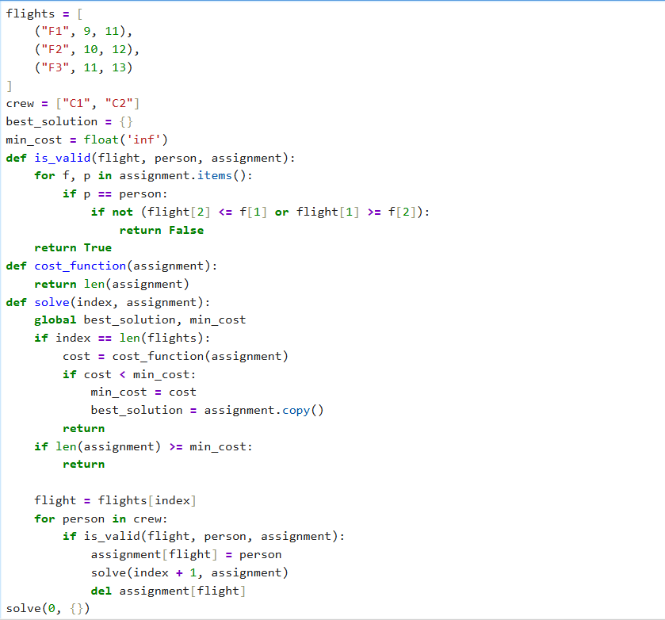

Output:-
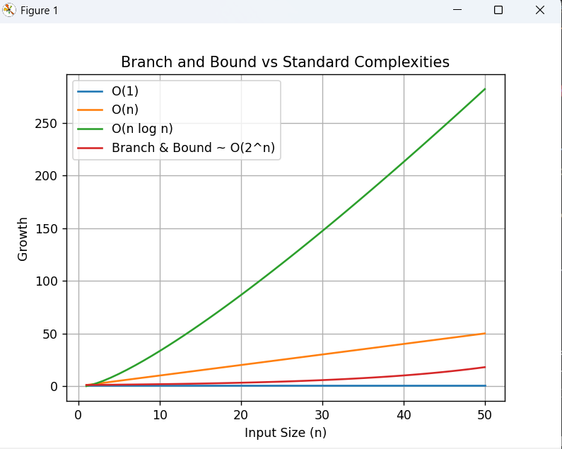

3. String Matching Algorithms:-
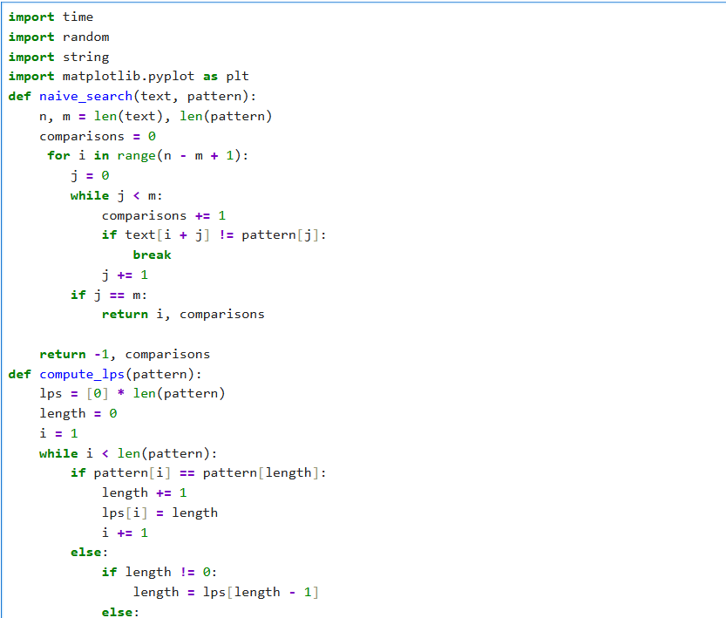
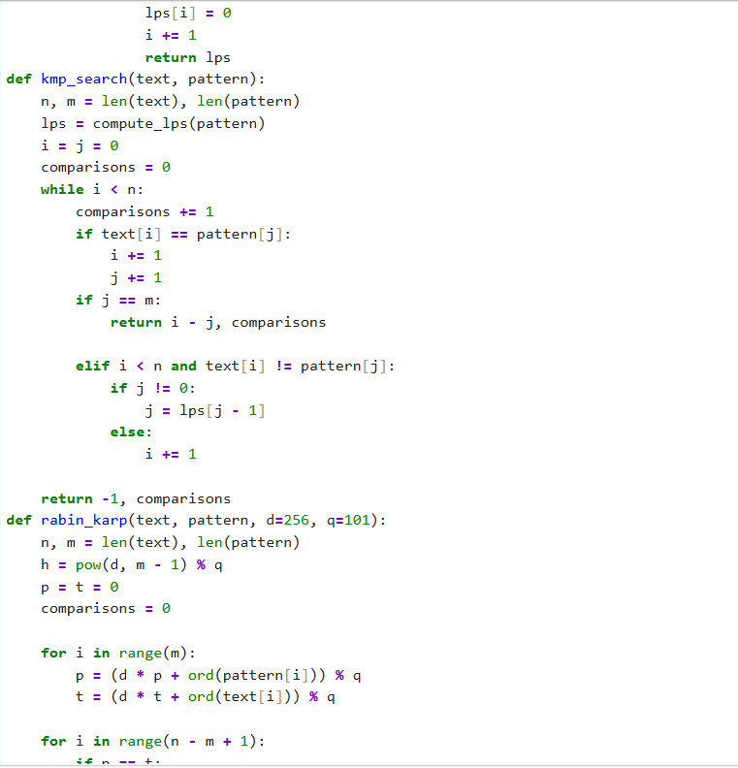
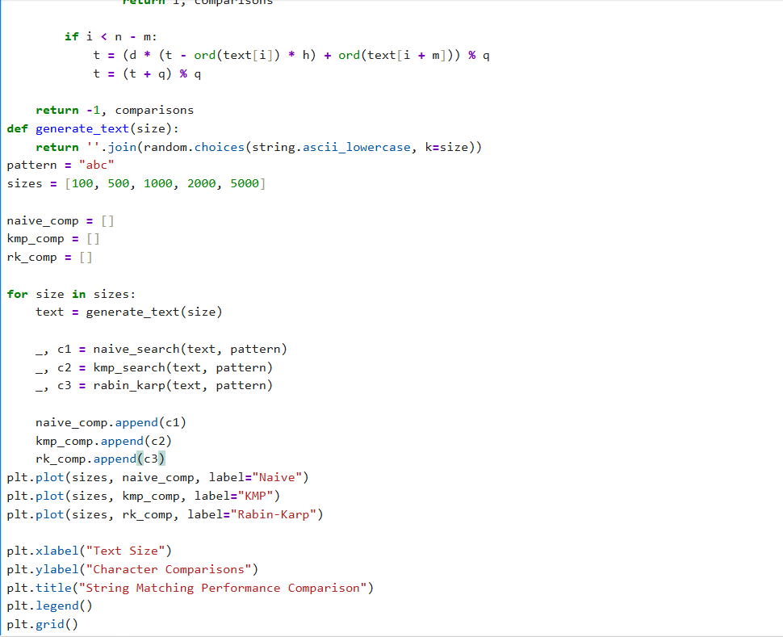
Output:-
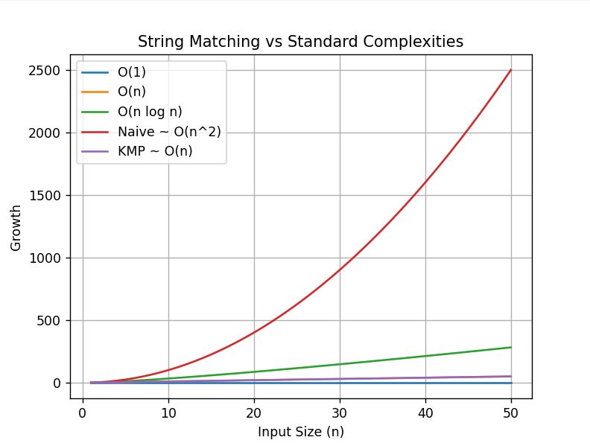

4. Experimental Comparison of String Matching :-
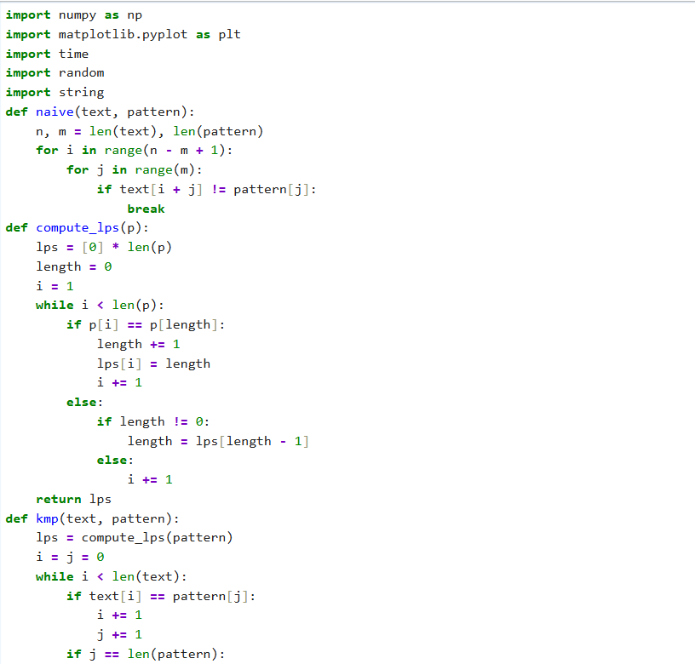
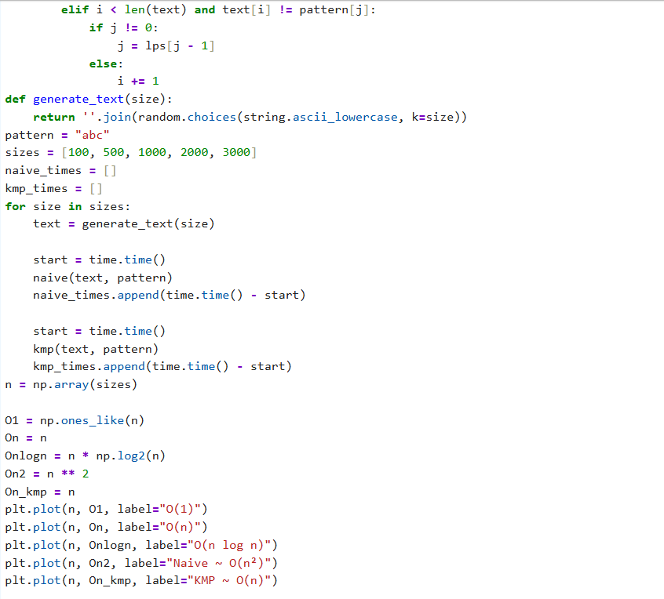
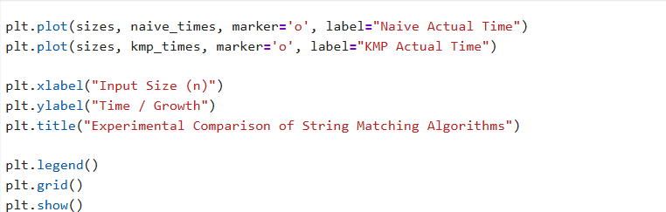

Output:-
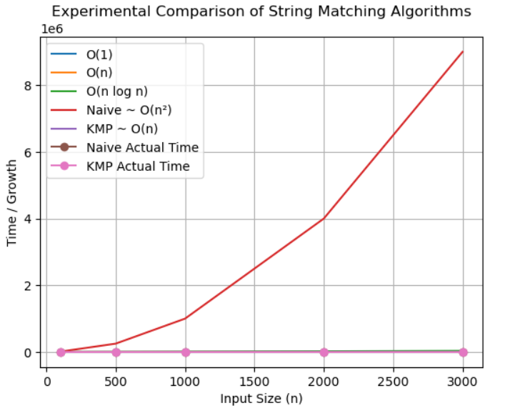

5. Conceptual Programming Tasks:-
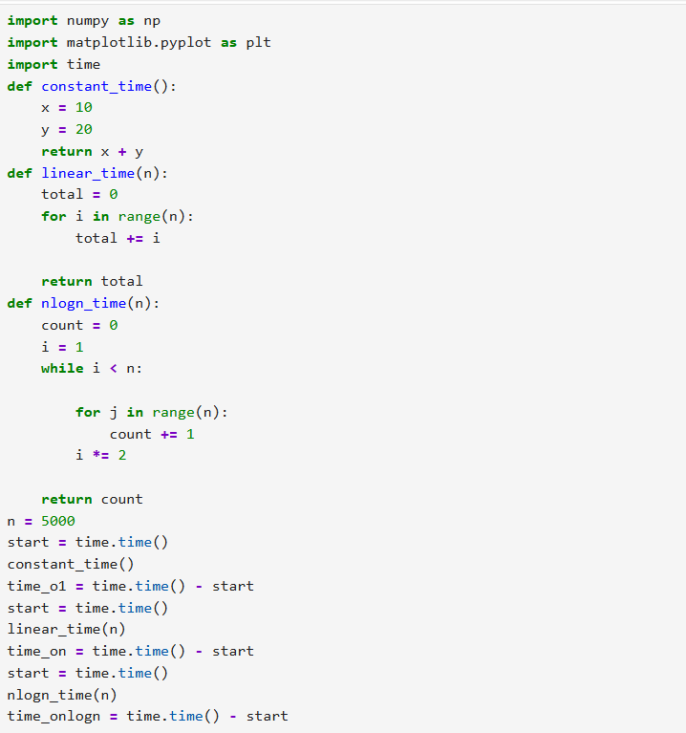
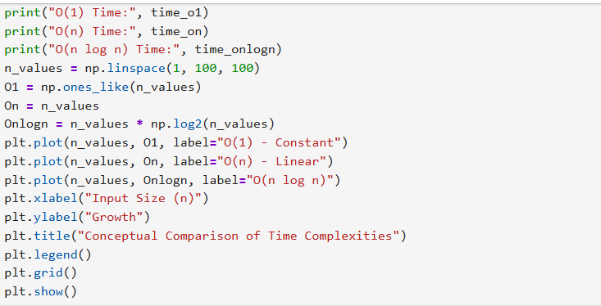

Output:-
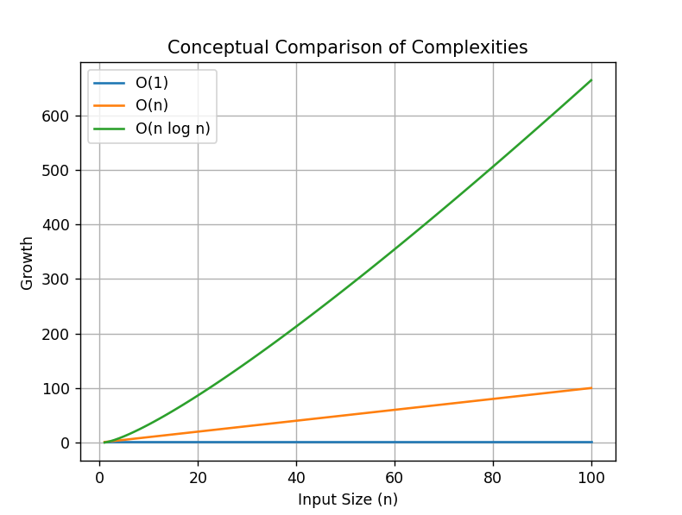
Github Link:- :- https://github.com/okayyymy15/MANYA_YADAV_ADA_ASSIGNMENTS.git

